Three Artists Commissions Available to create Sculptures/Features for Royds Street Gateway site to Woodnook Vale Nature Reserve rev a
Artists Quotation Brief
November 2018

Locations
This project focusses on 3 gateways into the new Nature Reserve:
- Miller Fold Avenue, approximate postcode BB5 0NT
- Perth Street, approximate postcode BB5 0QD
- Royds Street, approximate postcode BB5 2LH

The sites are easily accessible by vehicles for deliveries and for installation of sculptures/features.

Background to the project
Hyndburn Borough Council (HBC) have been working with Lancashire County Council to create a new nature reserve; the largest in Lancashire. This will be known as Woodnook Vale and was formally designated in July 2018.
As part of this project, HBC have secured grant funding to work with communities on improving 3 gateways into the site to highlight the entrances to the nature reserve and to make it more inviting.

The three chosen gateway sites all have a very different feel but are all key entrances to the new Nature Reserve.

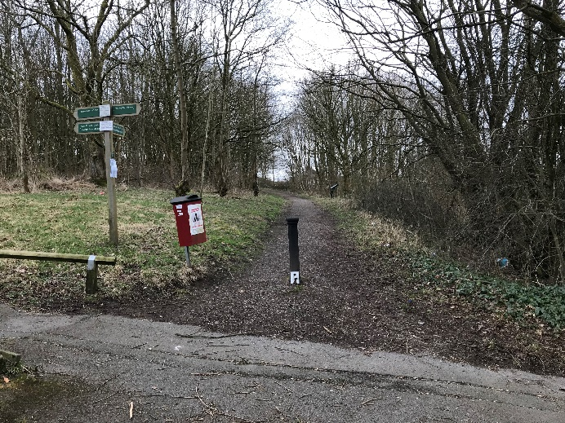

Royds Street is a well-used road linking schools to the local community. This is a wooded area between existing housing with a footpath directly into the Nature Reserve.

The Brief
To compliment the other gateway improvements such as installation of timber kneerail; tree planting and access improvements, we are looking to work with an artist and the community/schools to create a bespoke piece for the Royds Street entrance. The artwork must be site specific (possibly drawing on the rich and varied history of the area and fabulous wildlife to be found in the Nature Reserve) and it should be appropriate to the area and setting. They should also be robust and able to stand up not only to the elements but to vandalism too. The pieces should also be safe – as in free from finger/head traps, sharp edges and other features which could prove hazardous to children and the wider community.

It is likely that the finished pieces will be created from timber or metal depending on the site and the strengths of the artist.

General design points for all elements
Workshops
We would like the artwork to incorporate elements of design that comes from workshops with some/all of the following groups and schools:
- Lee Royd Nursery
- Woonook Primary School
- Hollins Secondary School
- The local community around the gateway site

Style
We would like the artworks to give an identity to each of this gateway site and be unique to that particular setting.
Through the consultation, the following has been suggested:

carved timber or metal feature which could double up as seating (formal or informal), potentially depicting wildlife found in and around the nature reserve. From community engagement, we know that birds are the most common wildlife in this area, including woodpeckers, owls and jays. Also deer are prevalent. We would also like the feature to include the words ‘Woodnook Nature Reserve’.

Construction and Installation
A principal contractor will be sought through a quotation process and it is presumed that they will install the sculptures/features if required once complete. The artist will be expected to liaise with the principal contractors regarding timing of the works and installation method.

Timescales
- Quotations available 29th November 2018
- Quotation return –Thursday 3rd January 2019 by 1pm
- Quotation assessment – w/c 7th January 2019
- Award of project – w/c 14th January 2019
- Engagement with community by artist/s and Proffitts to determine form/detail of sculptures – end January – February 2019
- Artist/s to work on designs for sculptures/features – end February into March 2019
- Artist/s to work on actual sculpture/features – March -April 2019
- Main construction work to commence on site by Principal Contractor – February - March 2019
- Sculptures available to main contractor for installation – end April 2019
- ALL works to be complete on site (including making good and snagging) – May 2019

Budget
There is an available budget of £3,000 – 4,000 for Royds Street

This should include for the art workshops with the schools/groups and design time for the artist to create the designs and actual sculptures/features for each of the gateways.

Please note that this budget does NOT include costs of installation as this will be carried out by the main contractor.

Submission Requirements
The submission should take the following format:
- Be A4 in format
- Be no longer than 6 pages long with the last page of this document as an additional document
- Submit one copy only
- Include details of how the artist intends to work with the groups/schools that have been highlighted
- Give suggestions of what form the sculpture/feature project might take and what it might include. Artists can choose to quote for one site, two sites or all 3 sites. This should be clearly stated in the tender submission.
- Give images and examples of similar work undertaken in the public realm previously as part of the submission
- Provide evidence of working with schools and the community on previous projects as part of the submission
- Include full cost breakdown for each element using the table set out below including a separate cost for painting artwork onto the seats if required.
- The successful artist(s) would need to demonstrate evidence of public liability insurance and a DBS Certificate

Assessment
The quotations will be assessed on several criteria, the weighting of which is shown below:
- Approach to workshops 10 marks
- How the artwork will reflect the Local Nature Reserve and create a sense of identity 10 marks
- Value for money 20 marks
- Methods in which you can add value to the project 10 marks

A total of 50 points are available.

Queries
Should you require clarification in respect of anything contained within this document, please put your enquiries in writing and email: rachael.gildert@proffittscic.com. Allow sufficient time for a response prior to the closing date. Correspondence sent elsewhere will not be processed.
We may circulate your query and the response to other Artists.

Site Visit
A site visit is recommended to get a feel for the site(s) and the surroundings to better inform the design process. The sites are fully open to the public at all times and it is recommended that artists make a visit to site before quoting.

Contact Rachael Gildert (Contract Administrator) at Proffitts on 07875 106084 if you want to discuss the quotation/project in more detail.

Tender Returns
Priced tenders are to be returned to Rachael Gildert at Proffitts via email at Rachael.gildert@proffittscic.com or posted c/o 1 Riverbank Mews, Loveclough, Rossendale, BB4 8TP

The deadline for receipt of tenders is Thursday 3rd January 2019 by 1pm.
Terms and Conditions

- The Quotation (including price) should remain valid for a minimum period of 90 days.
- Any signatures must be made by a person who is authorised to commit the artist to the Contract. Your full registered business/name and main office address must also be provided on all documents. Quotations will be disqualified if any of the following prevails:
  - The Quotation is received after the closing date / time specified above,
  - The Quotation envelope is marked with the name of the sender, e.g. franked.
- Artists are advised to copy their Quotation Submission and retain for future reference.
- Hyndburn Borough Council will not be bound to accept the lowest or any quotation and reserve the right to accept the whole or part of any quotation. Each party shall be responsible for its own costs in submitting this quotation.
- Costs should be on final page of submission and costs for each element are shown clearly and fully.
- Artists are required to return one copy of signed submission documents in hard copy format.
- Artists may be invited to attend a pre contract meeting / presentation with Woodnook Vale Local Nature Reserve Group, Proffitts and or Hyndburn Borough Council as part of the quotation process.

Tender Submission for Woodnook Vale Entrance Features at Royds Street

Item of Work to be carried out | Cost of time | Cost of materials (if applicable) | Total Cost
Carry out site visit to ascertain the layout of the site/s and to get inspiration for the sculpture/feature
Arrange and hold design and ideas workshop/s with primary school/s working alongside Proffitts and HBC
Work up a design (or designs) for the site(s) and share with HBC, Proffitts and the Working Group for comment
Carry out amendments to design if required and where applicable based on feedback from the steering group
Create actual physical sculpture/feature. Include cost of all materials required
Transport costs to get sculpture/feature to site (PROVISIONAL ITEM – the main contractor may be able to carry this out depending on the size and nature of each sculpture)
Include for liaising with main contractor regarding timings, delivery to site/collection from Studio etc.
TOTAL COST

Please note – if you want to work on more than one site, please provide a cost breakdown for each of the sites you want to work on.

I confirm that I have an up to date DBS Certificate:

I confirm that I have public liability insurance to the value of: £

Signed:

Name:

Name of Organisation
(where applicable)

Date:

